Connect / Disconnect
Send File
Log File
Clear Screen
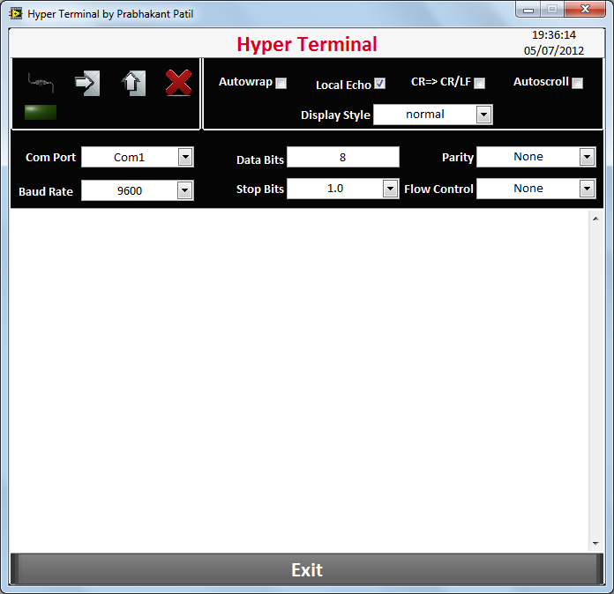
HyperTerminal is a program that you can use to connect to other computers, devices and host computers.
HyperTerminal has capabilities beyond making connections to other computers and devices. It can, for example, transfer large files from a computer onto your portable computer using a serial port rather than requiring you to set up your portable computer on a network. It can help debug source code from a remote terminal. It can also communicate with many older, character-based computers.
HyperTerminal records the messages passed to and from the computer on the other end of your connection. It can therefore serve as a valuable troubleshooting tool when setting up and using your serial port. To make sure that your device is connected properly or to view your device settings, you can send commands through HyperTerminal and check the results. HyperTerminal also has scroll functionality that enables you to view received text that has scrolled off the screen.
Control Name | Description
Connect / Disconnect | Clicking on this button, selected com port will connect or disconnect.
Send File | Clicking on this button, file section window will open. User can select the file which supposed to send.
Log file | Clicking on this button, User can log the data to the selected file.
Clear Screen | Clicking on this button, the display screen will be cleared
Autowrap | This will wrap the text
Local Echo | This will generate an echo
CR=> CR/LF | Send End character
Auto scroll | Will scroll display automatically
Display Style | Select the display style, like Normal, Hex code display
Exit | Clicking on this button, application will exit.

